**Lesson 4 Demo 13**

**Understanding Config Maps and Secrets**



Steps to be followed:

1. Adding Config Map entry to the Pod
2. Creating secrets using kubectl

**Step 1: Adding Config Map entry to the Pod**

1. Create a config map configuration file:

***vi configmapdemo.yaml***



1. Add the following code to the configmapdemo.yaml file:

***apiVersion: v1***

***kind: ConfigMap***

***metadata:***

***name: game-demo***

***data:***

***player_initial_lives: "3"***

***ui_properties_file_name: "user-interface.properties"***

***game.properties: |***

***enemy.types=aliens,monsters***

***player.maximum-lives=5***

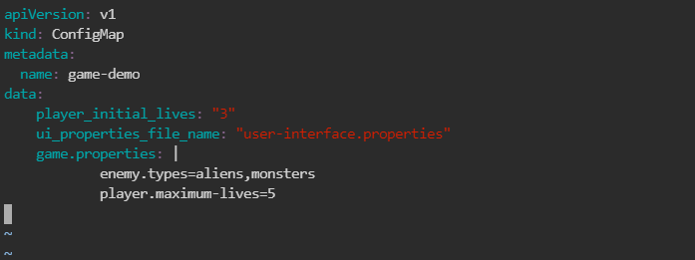

1. Type the following command to apply the changes:

***kubectl apply -f configmapdemo.yaml***



1. List the ConfigMaps using the below command:

***kubectl get configmaps***

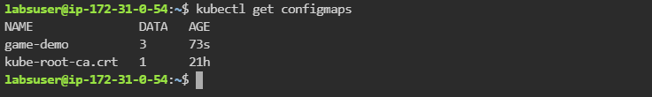

1. Create a pod config file:

***vi configmapsample.yaml***



1. Add the following code to the **configmapsample.yaml** file:

***apiVersion: v1***

***kind: Pod***

***metadata:***

***name: mypod***

***spec:***

***containers:***

***- name: mypod***

***image: redis***

***ports:***

***- containerPort: 80***

***volumeMounts :***

***- name: sample***

***mountPath: /home/labsuser/configfiles/***

***readOnly: true***

***volumes :***

***- name: sample***

***configMap:***

***name: game-demo***

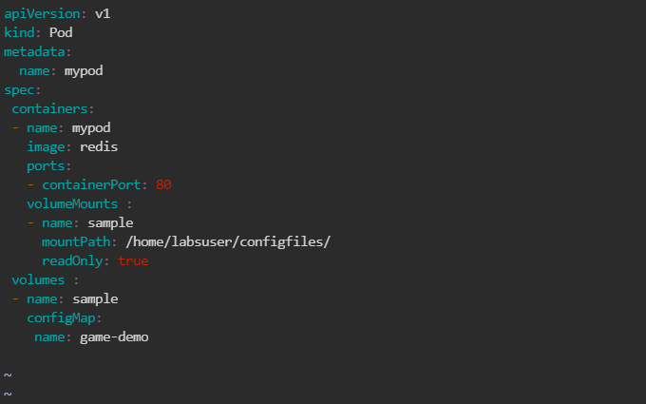

1. Configure the pod by executing the following command:

***kubectl apply -f configmapsample.yaml***



1. Run the following command to describe the pod:

***kubectl describe pod mypod***

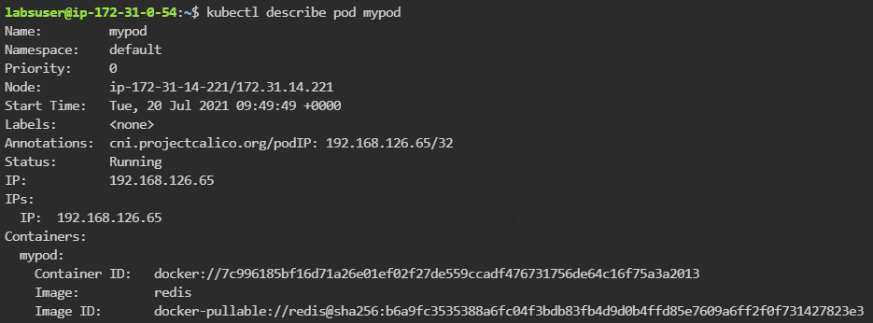

**Step 2: Creating secrets using kubectl**

1. Execute the following commands to create secrets:

***kubectl create secret generic dev-db-secret \***

***--from-literal=username=devuser \***

***--from-literal=password='Simplilearn#123'***

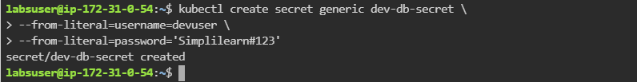

1. Verify the secret by executing below command:

***kubectl get secrets***

